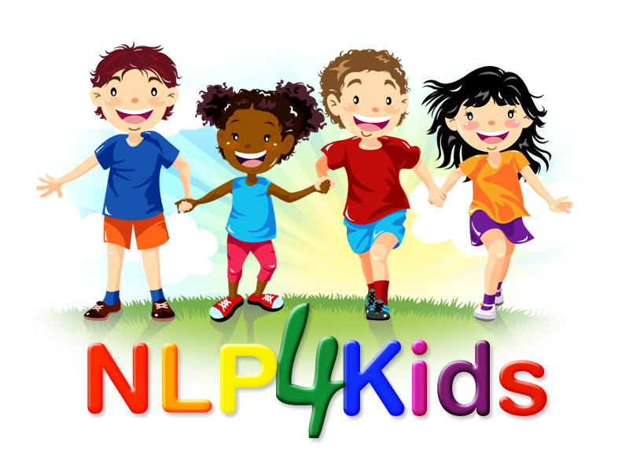
Parents Workshop
Learn how to:
- communicate and connect well with your children.
- the types of language that helps to communicate and connect well.
- how to teach and learn about responsibility, cause and effect and how mind reading can work in us all.
- identify how problems meet our needs and how to create successful relationships with your children, identifying things that are not working and what we need to do next.
- techniques to help your child to have positive self- talk, positive emotional states and communicate better with others.
The course will include presentations, discussion time and a course workbook.
When: Thursday 18th July and Thursday 25th^{th} July from 7:00 to 8:30pm
Where: On Zoom
How to book: Email: Naomi@NLP4Kids.org
Licensed Practitioner of NLP4Kids
Please book by the 15th July

Website: www.cheshirechildandfamilytherapist.nlp4kids.org

